Impact of a multi-Cancer Early Detection screening programme in England on diagnostic demand - a modelling study: Uptake scenario 70% CSO accuracy 0.93

Figure 1: Monlthy time series of English diagnostic modality usage from April 2018 to April 2024
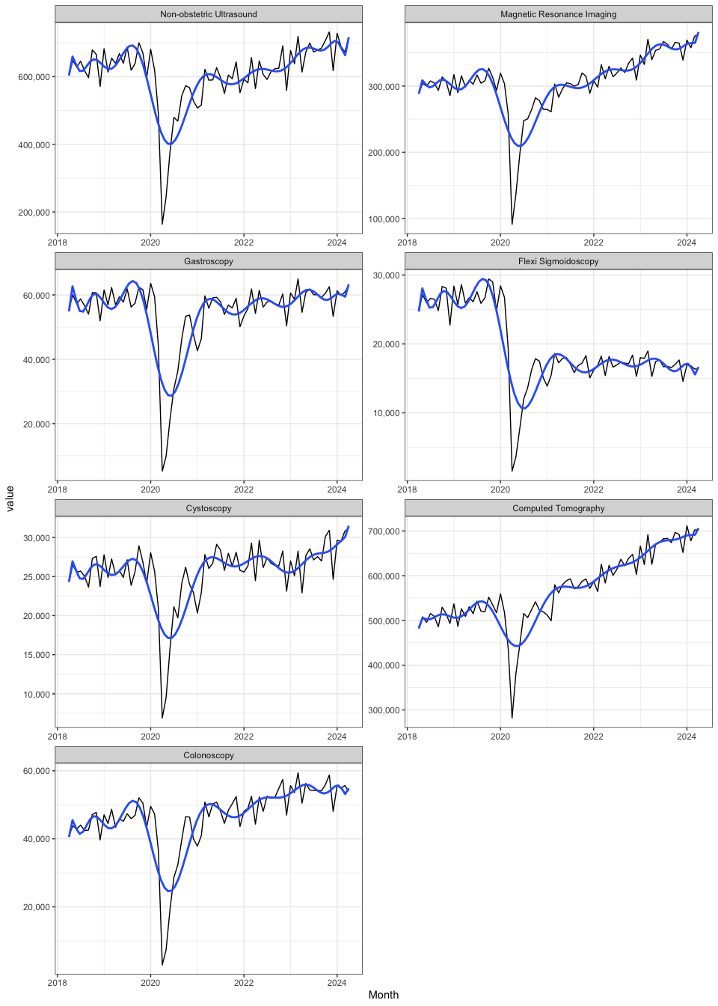

Results table 1: Increase in annual diagnostic modality usage in relation to English total usage for the period May 2023 to Aprial 2024
 |  | Prevalent round |  |  |  |  | Steady state
 |  | MCED screening programme scenario |  |  | Per 1 million screened |  | MCED screening programme scenario |  |  | Per 1 million screened
Diagnostic modality | Total usage in England 2023/24 | Estimated annual use (n) associated with MCED screening | Percentage (%) increase in total annual usage | Percentage increase attributable to true (false) positives | Estimated annual use (n) associated with MCED screening | Percentage (%) increase in total annual usage | Estimated annual use (n) associated with MCED screening | Percentage (%) increase in total annual usage | Percentage increase attributable to true (false) positives | Estimated annual use (n) associated with MCED screening | Percentage (%) increase in total annual usage
Biopsy | NA | 27710 | NA | NA (NA) | 2100 | NA | 10170 | NA | NA (NA) | 770 | NA
Colonoscopy | 656100 | 54270 | 8.27 | 2.69 (5.58) | 4110 | 0.63 | 17850 | 2.72 | 0.88 (1.84) | 1350 | 0.21
Computed Tomography | 8221600 | 198100 | 2.41 | 0.39 (2.02) | 15000 | 0.18 | 70610 | 0.86 | 0.14 (0.72) | 5350 | 0.07
Cystoscopy | 344600 | 5520 | 1.60 | 0.5 (1.1) | 420 | 0.12 | 1810 | 0.53 | 0.16 (0.36) | 140 | 0.04
Flexi Sigmoidoscopy | 200900 | 1600 | 0.80 | 0.25 (0.55) | 120 | 0.06 | 650 | 0.32 | 0.1 (0.22) | 49 | 0.02
Gastroscopy | 723200 | 36300 | 5.02 | 1.58 (3.44) | 2750 | 0.38 | 12700 | 1.76 | 0.55 (1.2) | 960 | 0.13
Magnetic Resonance Imaging | 4346300 | 6970 | 0.16 | 0.05 (0.11) | 530 | 0.01 | 3370 | 0.08 | 0.02 (0.05) | 260 | 0.01
Non-obstetric Ultrasound | 8267800 | 52170 | 0.63 | 0.2 (0.43) | 3950 | 0.05 | 19340 | 0.23 | 0.07 (0.16) | 1460 | 0.02

